Sample Paper: <http://cs229.stanford.edu/proj2012/ChongLiu-MaliciousURLDetection.pdf>

Assumptions: -1: Legitimate, 0: Suspicious, 1: Phishing

**Abstract**

**Introduction**

Phishing is a cyberattack rooted in scare tactics, with the sole purpose of eliciting personally identifiable information (PII) from its victims. An attacker disseminates a fraudulent version of a legitimate website, usually via email, telephone or text messages [1], in the hopes that the victim would believe the claims made in the email. A successful phishing attack can result in an attacker obtaining credit card details and login information.

Why phishing is important to research.

Why we choose machine learning to detect phishing: easy to implement, have high accuracy and recall rates, over traditional methods, black and whitelists.

Differentiate among 3 types of phishing [2] and state that we are going to focus on web based phishing.

**Our Research Goal**

Our project aims to identify the most relevant subset of features that can accurately identify phishing URLs, using Random Forests algorithm together with five different subsets of features.

**Related Work**

**Methodology/System Design**

Brief overview of our classification scheme. How it works.

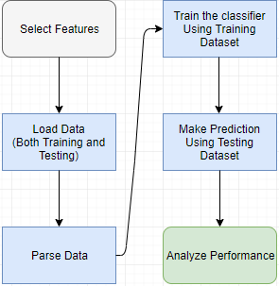

**SubSect: Data**

We collected our training and test data from the UCI phishing dataset [6] that is publicly available. This dataset contained 2456 unique URL instances and a total of 11,055 URLs of which 6,157 are phishing and 4,898 are legitimate sites. Each row represented a URL and each URL was previously parsed and represented according to 30 features which could determine whether or not the URL is used for phishing or just identify a specific feature as suspicious for a particular URL. The features considered includes whether or not an IP Address is used instead of a URL, the length of the URL, the presence of link tags to the same domain as the webpage and whether or not the webpage uses IFrames. At the end of each row, there is a result which identifies the true nature of the URL, 1 if it is a phishing site and -1 if it a legitimate site.

Fix this paragraph:

Our dataset is made up of discrete data. This means each feature can only be represented by -1, 1 and sometimes 0. Random Forest also proves to be highly efficient when working with large datasets. We used 10,000 URLs for training and 1,055 for testing. The test data contained 461 phishing sites and 594 legitimate sites. Our belief is that using more features to train the algorithm should result in better predictions, and hence higher accuracy, recall and F1 scores, for the test data

**SubSect: Feature Selection**

In any classification scheme, there are features which seem more prominent than others in achieving a correct classification. These features, combined with other salient features or even less salient features, can perform outstandingly. The difficulty arises when we must determine what are the most relevant features from a set and what combination of features give us near perfect classification accuracies. From the 30 features, we identified five subsets. These were grouped as shown below.

~~Set A: Features we think are most important.~~

~~Having_IP_Address, URL_Length, having_At_Symbol, Domain_registration_length, links_in_tags, submitting_to_email, Iframe, age_of_domain, having_Sub_Domain, Redirect.~~

~~0, 1,3,8,14,16,18,22,23 (A-68.90%)~~

Set A: Web-presence related features. We chose these four features to determine if it is practical to determine the nature of a URL simply by looking at its presence on the internet, and not by any structural features of the URL itself. These features included: Domain age, Website traffic, Page Rank, Google Index.

23,25,26,27 (A-50.42%) 4 features

Set B: Features with only two (2) possible outcomes {-1,1}. This makes the data more binary and eliminates the possibility of uncertain URLs. 21 features

having_IP_Address, Shortining_Service, having_At_Symbol, double_slash_redirecting, Prefix_Suffix, Domain_registeration_length, Favicon, port, HTTPS_token, Request_URL, Submitting_to_email, Abnormal_URL, Redirect, on_mouseover, RightClick, popUpWidnow, Iframe, age_of_domain, DNSRecord, Page_Rank, Google_Index, Statistical_report.

0,2,3,4,5,8,9,10,11,12,16,17,19,20,21,22,23,24,26,27,29 (A-76.77%)

Set C: Features with three (3) possible outcomes {-1,0,1}. These features allows for uncertainty in their output and includes: 8 features

1,6,7,13,14,15,25,28 (A-94.12%) Figure out WHY this is so good!

URL_Length, having_Sub_Domain, SSLfinal_State, URL_of_Anchor, Links_in_tags , SFH, web_traffic, Links_pointing_to_page.

Set D: All 30 features (A- 95.73%)

Set E: The most important features (those rated 0.01 and up) according to classifier.feature_importances_ function. These include:

0,1,5,6,7,8,12,13,14,15,23, 24, 25, 26, 27, 28 (A-96.20%) 16 features

having_IP_Address, URL_Length, Prefix_Suffix, having_Sub_Domain, SSLfinal_State, Domain_registeration_length, HTTPS_token, Request_URL ,URL_of_Anchor ,Links_in_tags ,SFH ,age_of_domain ,DNSRecord,web_traffic,Page_Rank ,Google_Index,Links_pointing_to_page

1. SFH { -1,1,0 }
2. Submitting_to_email { -1,1 }
3. Abnormal_URL { -1,1 }
4. Redirect { 0,1 }
5. on_mouseover { 1,-1 }
6. RightClick { 1,-1 }
7. popUpWidnow { 1,-1 }
8. Iframe { 1,-1 }
9. age_of_domain { -1,1 }
10. DNSRecord { -1,1 }
11. web_traffic { -1,0,1 }
12. Page_Rank { -1,1 }
13. Google_Index { 1,-1 }
14. Links_pointing_to_page { 1,0,-1 }
15. Statistical_repo {-1,1}
16. having_IP_Address { -1,1 }
17. URL_Length { 1,0,-1 }
18. Shortining_Service { 1,-1 }
19. having_At_Symbol { 1,-1 }
20. double_slash_redirecting { -1,1 }
21. Prefix_Suffix { -1,1 }
22. having_Sub_Domain { -1,0,1 }
23. SSLfinal_State { -1,1,0 }
24. Domain_registeration_length { -1,1 }
25. Favicon { 1,-1 }
26. port { 1,-1 }
27. HTTPS_token { -1,1 }
28. Request_URL { 1,-1 }
29. URL_of_Anchor { -1,0,1 }
30. Links_in_tags { 1,-1,0 }

**SubSect: Experiment Design**

**Experiment Design**

Brief overview of Random Forest:

Random Forest is a supervised classification algorithm that makes use of several classification trees [7]. A classification is made by passing each input vector down each tree, randomly. Each tree gives a classification, or vote, and the forest chooses the classification with the most instances, or votes [8]. We decided to use this algorithm because it is unexcelled in accuracy among its counterparts [8], it runs efficiently on large datasets and it can handle missing values [7].

Libraries used

How we parse the data into the different matrices.

**SubSect: Evaluation Methods**

To fully evaluate the effectiveness of a classification model, you must include its precision and recall scores. In order to evaluate the performance of our classifications, we’ve calculated the Accuracy, Precision, Recall and F1 Scores for each set tested.

Precision measures the number of instances that have been correctly classified and is a measure of the classifier’s exactness. It is the number of positive predictions divided by the total number of positive instances predicted. For us, precision answers the question, “Of all the URLs labeled as phishing, how many are actually phishing?” The formula to calculate precision is given by Equation 1 below.

Precision: P = TP/TP + FP - all correct classified / all classified

Recall measures the number of positive instances that the classifier correctly identified from the set of all positive instances. In other words, recall measure the number of instances that were missed [1]. Recall is a measure of the classifier’s completeness. For us, recall answers the question, “Of all the URLs that are truly phishing, how many did we identify as phishing?” The formula to calculate recall is given by Equation 2 below.

Recall: R = TP/TP + FN - all correct classified / should be classified

If a machine learning algorithm is good at recall, it doesn’t mean that algorithm is good at precision. That’s why we also need F1 score which is the (harmonic) mean of recall and precision to evaluate an algorithm.

Simply looking at a classifier’s precision and recall scores would be not constitute a substantial evaluation. As such, we include the F1 score, which is the weighted average of precision and recall scores. The formula to calculate F1 Score is given by Equation 3 below.

//F1 weight the Precision and Recall, in other word choose which one is more important, Default is P = R

$$TPR=\frac{TP}{TP+FN}$$

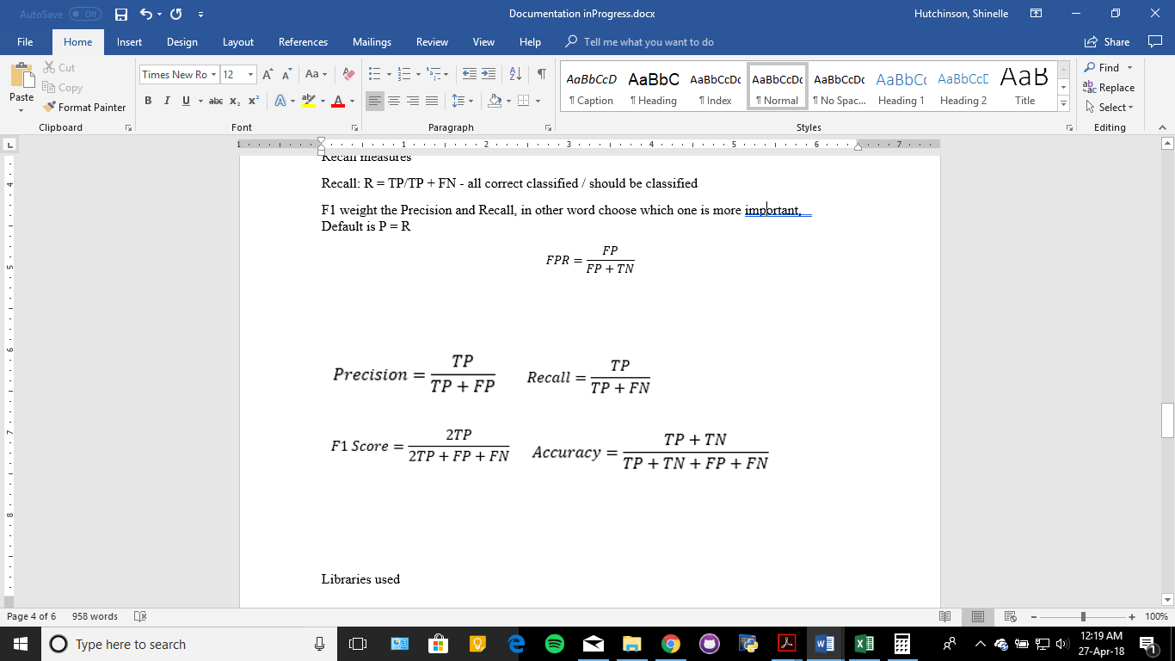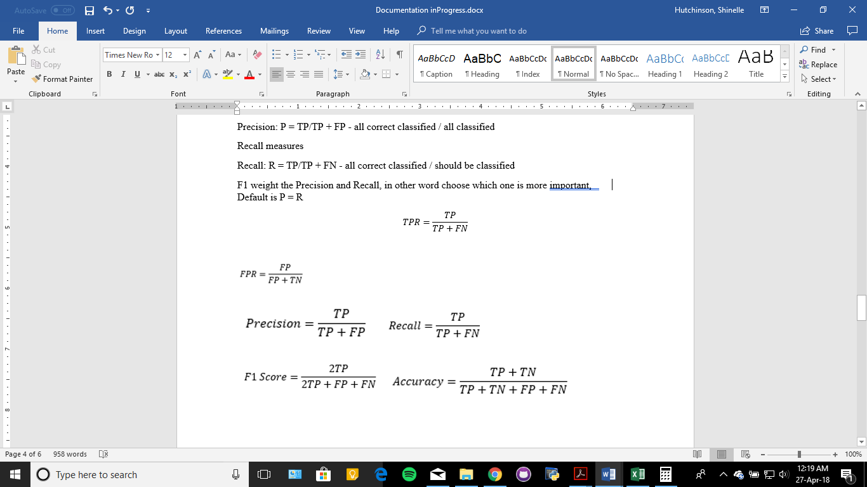

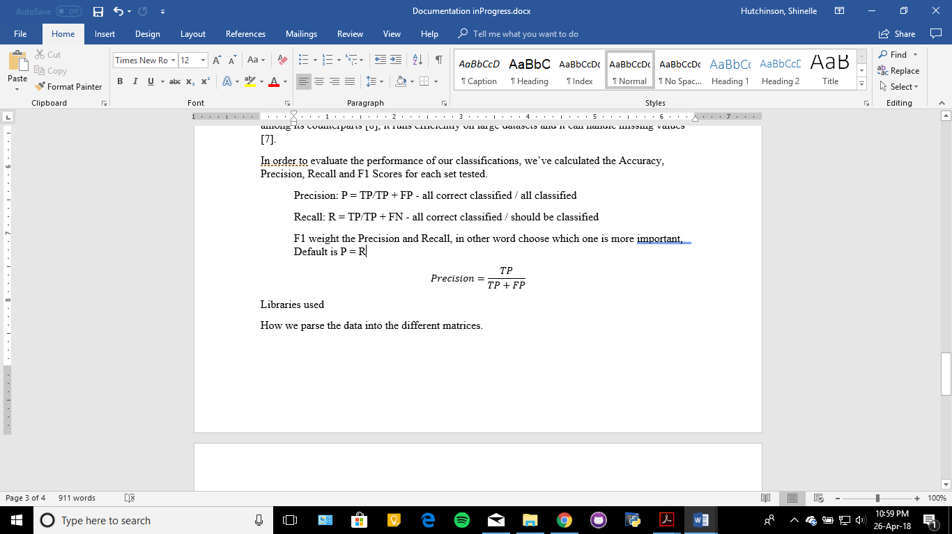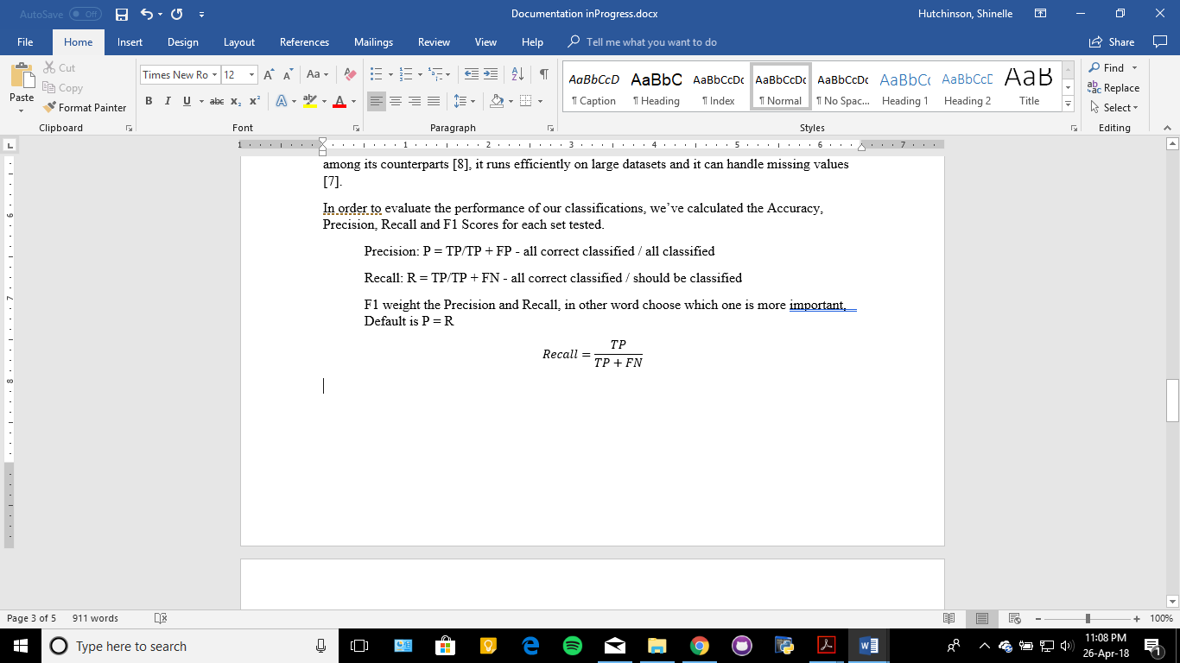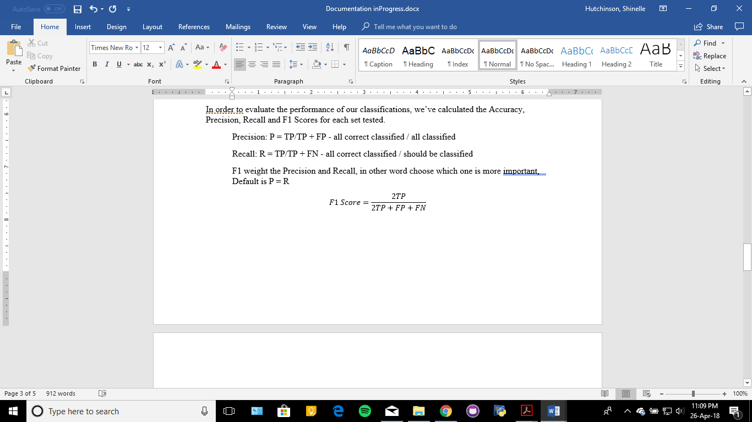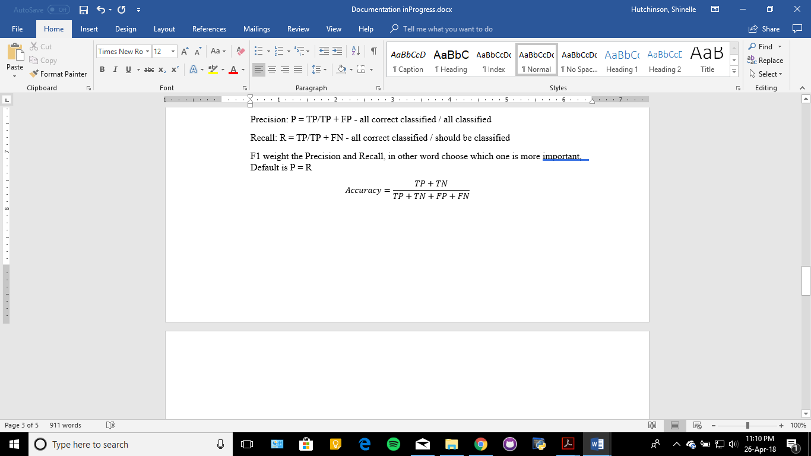

Accuracy, simply put, is the number of correct classifications made out of all instances in the test data. The formula to calculate accuracy is given by Equation 4 below

The Receiver Operating Characteristic (ROC) curve is ideal for representing binary classifications like this one. The curve is plotted with the False Positive Rate (FPR) on the x-axis and the True Positive Rate (TPR) or recall, on the y-axis. The formulas to calculate FPR and TPR are given by Equations 5 and 6 below.

**SubSect: Results**

-Performance

**Discussion:**

Why Set performed so well?

Why Set B did so bad?

Comment on feature importance and Set E outperforming the other sets.

**SubSet Limitations**:

Had to stick to the format of the dataset.

Some of our subsets were build based on our judgement of feature importance, ie Sets A, B and C.

**Conclusion:**

State our success of improving accuracy, precision and recall of the original system design using select features from all 30 features.

**Future Work:**

Include more features, find more important features, and combine all important features in hopes of achieving near perfect accuracy and precision.

Design our own URL parser to include additional features.

Better method of selecting feature sets, eg. By using forward feature selection and backward feature elimination methods.